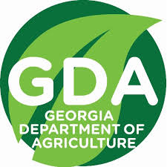
Pesticide Clean Day Event

Date & Time  August 16, 2023  9:00am – 3:00pm | Location  Tri County Gin (Coffee Co.)  561 Sinkhole Rd. Douglas, Ga. 31535

Georgia Dept. of Agriculture Clean Day is a program that gives everyone an opportunity to discard old, unusable, or cancelled pesticides to a hazardous waste contractor for disposal. Pesticides in leaking containers or disposed of improperly may cause environmental damage by contaminating water supplies or harming people and wildlife. Some pesticides that have been used in the past are now in need of proper disposal. Participation in the Clean Day Program remains free of charge to all private and commercial applicators with the understanding that the event is designed / intended for farmers, lawn care, golf courses, and pest control companies. The Georgia Department of Agriculture we will be requiring pre-registration for the events. For more information about the event please contact your local extension agent, visit our website: https://agr.georgia.gov/georgia-clean-day or contact Rick Hayes coordinator for the event at ricky.hayes@agr.georgia.gov (Office: 404-656-4958) (Cell: 404-535-1614)
This is an excellent opportunity to dispose of pesticides that you have been holding because you had neither an economical nor legal means to dispose of them. Canceled and suspended pesticides by definition cannot be used and must be disposed of often as hazardous waste. Some reasons to participate in this program are:
1. No disposal fees for those who participate in the program.

2. The disposal contractor secures all permits and approvals.

3. Disposal contractor takes possession of the waste and thereby becomes the generator.

4. All materials eligible for destructive incineration will be destroyed.

5. Minimization of ongoing liabilities from continued storage of these wastes on your property.

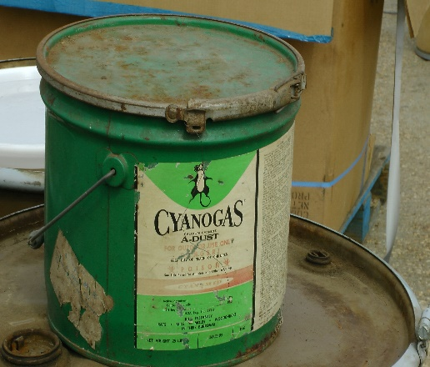

Ag Dealers special arrangements can be made to accommodate you. Your pesticide waste disposal will be weighed and billed on site.
Please Contact Rick Hayes for special instructions! ricky.hayes@agr.georgia.gov
· PRE-REGISTRATION IS MANDATORY FOR PROGRAM PARTICIPATION. Visit our website for pre-registration forms. https://agr.georgia.gov/pesticide-waste-disposal-container-recycling
· ALL PESTICIDES BROUGHT TO THE COLLECTION SITE MUST BE LISTED ON THE PRE-REGISTRATION FORM.
· ITEMS NOT REGISTERED WILL BE REFUSED AT THE COLLECTION SITE.
· EMPTY CONTAINERS OR RINSATES WILL NOT BE ACCEPTED.
· NO COMPRESSED GASES CAN BE ACCEPTED. (METHYL BROMIDE, CHLORPICRIN, VIKANE, ETC.).

All canceled, suspended, unusable and unlabeled materials classified as pesticides may be turned in for collection. Please refer to the brief list below to determine what types of materials will or will not be accepted at the event. Please list all pesticides to be turned in on the pre-registration form in order to estimate types and volumes to be collected. Any pesticides without a brand name, trade name, or active ingredient on the label may require analysis to determine the contents. Please label all unidentifiable pesticides as “unknown” on the pre-registration form.

EXCLUDED MATERIALS
Compressed Gases
Solvents
Paints
Antifreeze
Motor Oil
Explosive Materials
Fertilizers or Nutrients that are neither hazardous or do not contain pesticide admixtures
ACCEPTABLE MATERIALS
Insecticides
Growth Regulators
Fungicides
Harvest Aid Chemicals
Nematicides
Bactericides
Herbicides
Miscellaneous pesticides

